Question?:

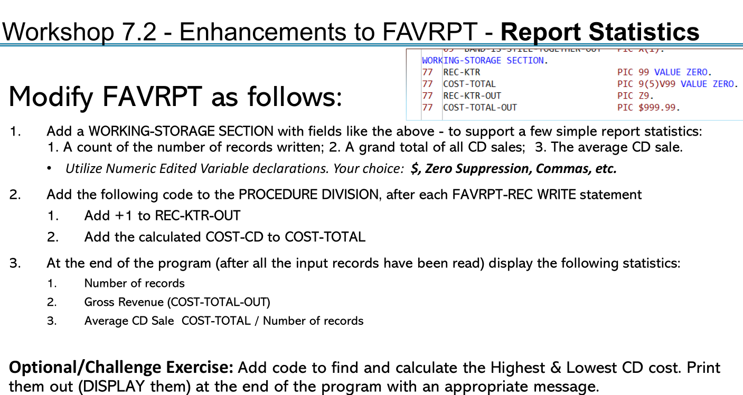

Answer : PROGRAME NAME FAVRPTV2

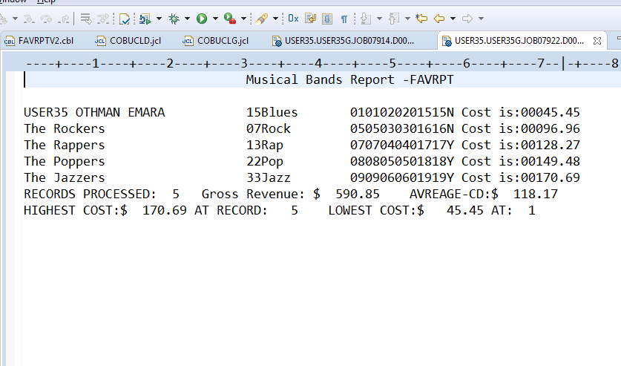

IDENTIFICATION DIVISION.

PROGRAM-ID. FAVRPTV2.

\*\*\*\*\* This MODULE Workshop 5.3.1b - Create new COBOL program

\*\*\*\*\* THAT USES A FILE READ

\*\*\*\*\* VERSION 2 Workshop 7.2 THAT MAKE CLAUCLATION PRINT AVERAGE

ENVIRONMENT DIVISION.

INPUT-OUTPUT SECTION.

FILE-CONTROL.

SELECT FAVIN1 ASSIGN TO FAVIN

FILE STATUS IS FAVIN-F-STATUS.

SELECT OUT2 ASSIGN TO FAVRPT.

DATA DIVISION.

FILE SECTION.

FD FAVIN1

RECORDING MODE IS F

LABEL RECORDS ARE STANDARD

RECORD CONTAINS 80 CHARACTERS

BLOCK CONTAINS 0 RECORDS

DATA RECORD IS FAVIN-REC.

01 FAVIN-REC.

05 ARTIST-NAME PIC X(30).

05 NUMBER-OF-MUSICIAN PIC 9(02).

05 MUSICAL-GENRE PIC X(12).

05 COST.

10 CD-COST PIC 9(3)V99.

10 SHIPPING-COST PIC 9(2)V99.

10 TAX PIC 9(2)V99.

05 BAND-IS-STILL-TOGETHER PIC X(1).

FD OUT2

RECORDING MODE IS F

LABEL RECORDS ARE STANDARD

RECORD CONTAINS 80 CHARACTERS

BLOCK CONTAINS 0 RECORDS

DATA RECORD IS FAVOUT-REC.

01 FAVOUT-REC.

05 ARTIST-NAME-OUT PIC X(30).

05 NUMBER-OF-MUSICIAN-OUT PIC 9(02).

05 MUSICAL-GENRE-OUT PIC X(12).

05 COST-OUT.

10 CD-COST-OUT PIC 9(3)V99.

10 SHIPPING-COST-OUT PIC 9(2)V99.

10 TAX-OUT PIC 9(2)V99.

05 BAND-IS-STILL-TOGETHER-OUT PIC X(1).

05 COST-IS PIC X(9) VALUE ' Cost is:'.

05 COMPUTED-COST-OUT PIC 9(5).99.

WORKING-STORAGE SECTION.

01 HEADER-1.

05 FILLER PIC X(30) VALUE SPACES.

05 FILLER PIC X(30) VALUE 'Musical Bands Report -FAVRPT'.

05 FILLER PIC X(20) VALUE SPACES.

01 TRAILLER-1.

05 FILLER PIC X(18) VALUE 'RECORDS PROCESSED:'.

05 REC-KTR-OUT PIC ZZ9 .

05 FILLER PIC X(18) VALUE ' Gross Revenue:'.

05 COST-TOTAL-OUT PIC $ZZZZZ.99 .

05 FILLER PIC X(15) VALUE ' AVREAGE-CD:'.

05 AVREAGE-CD-SALE-OUT PIC $ZZZZZ.99 .

01 TRAILLER-2.

05 FILLER PIC X(13) VALUE 'HIGHEST COST:'.

05 CD-COST-HIGHEST-D PIC $ZZZZZ.99 .

05 FILLER PIC X(13) VALUE ' AT RECORD: '.

05 REC-NO-HIGHEST-D PIC Z9 .

05 FILLER PIC X(16) VALUE ' LOWEST COST:'.

05 CD-COST-LOWEST-D PIC $ZZZZZ.99 .

05 FILLER PIC X(5) VALUE ' AT: '.

05 REC-NO-LOWST-D PIC Z9 .

\* JUST TO DEBUG ANY DATA OUT

01 DEBUG-REC.

05 FILLER PIC X(5) VALUE 'DEBUG'.

05 FILLER PIC X(13) VALUE ' file status:'.

05 FAVIN-F-STATUS PIC X(2).

05 FILLER PIC X(4) VALUE ' LR:'.

05 LASTREC PIC X VALUE SPACES.

88 STELL-THERE-REC VALUE ' '.

88 NO-MORE-RECORDS VALUE 'Y'.

05 DBG-MESSAGE-ALL.

10 DBG-MESSAGE.

15 DBG-MSG1 PIC X(15).

15 DBG-MSG2 PIC X(15).

10 DBG-MSG3 PIC X(10).

10 DBG-MSG4 PIC X(10).

10 DBG-MSG5 PIC X(5).

01 COST-DEBUG.

10 CD-COST-D PIC 9(3).99.

10 FILLER PIC X(3) VALUE ' + '.

10 SHIPPING-COST-D PIC 9(2).99.

10 FILLER PIC X(3) VALUE ' + '.

10 TAX-D PIC 9(2).99.

\* COMPUTED DATAITEMS

77 COMPUTED-COST PIC 9(5)v99.

77 REC-KTR PIC 99 VALUE ZEROS .

77 REC-NO-HIGHEST PIC 99 VALUE ZEROS .

77 REC-NO-LOWEST PIC 99 VALUE ZEROS .

77 COST-TOTAL PIC 9(5)V99 VALUE ZEROS .

77 AVREAGE-CD-SALE PIC 9(5)V99 VALUE ZEROS .

77 CD-COST-HIGHEST PIC 9(3)V99 VALUE ZEROS .

77 CD-COST-LOWEST PIC 9(3)V99 VALUE ZEROS .

PROCEDURE DIVISION.

OPEN INPUT FAVIN1.

OPEN OUTPUT OUT2.

WRITE FAVOUT-REC FROM HEADER-1.

MOVE SPACES TO FAVOUT-REC.

WRITE FAVOUT-REC AFTER ADVANCING 1 LINES.

\* Prime Read

PERFORM READ-RECORD.

PERFORM UNTIL LASTREC = 'Y' OR NO-MORE-RECORDS

PERFORM PROCESS-RECORDS

PERFORM WRITE-RECORD

PERFORM READ-RECORD

END-PERFORM

PERFORM WRITE-LAST-REC

PERFORM CLOSE-FILES

STOP RUN.

READ-RECORD.

READ FAVIN1

\* AT END MOVE 'Y' TO LASTREC

AT END

PERFORM END-OF-FILE

\* NOT AT END PERFORM PROCESS-RECORDS

END-READ.

PROCESS-RECORDS.

COMPUTE COMPUTED-COST =(CD-COST + SHIPPING-COST + TAX).

COMPUTE REC-KTR = REC-KTR + 1 .

IF COMPUTED-COST > 0 AND REC-KTR = 1 THEN

COMPUTE CD-COST-HIGHEST = COMPUTED-COST

COMPUTE CD-COST-LOWEST = COMPUTED-COST

COMPUTE REC-NO-LOWEST = 1

COMPUTE REC-NO-HIGHEST = 1

END-IF.

\* Accumulate COST-TOTAL

COMPUTE COST-TOTAL = (COST-TOTAL + COMPUTED-COST).

MOVE CD-COST TO CD-COST-D .

MOVE SHIPPING-COST TO SHIPPING-COST-D .

MOVE TAX TO TAX-D .

MOVE SPACES TO DBG-MESSAGE-ALL.

PERFORM GET-HIGHEST-LOWEST-CD-COST.

\* MOVE ' P-RCD ' TO DBG-MSG1 .

\* WRITE FAVOUT-REC FROM DEBUG-REC.

\* Just to print debug data

\* MOVE COST-DEBUG TO DBG-MESSAGE .

\* WRITE FAVOUT-REC FROM DEBUG-REC.

WRITE-RECORD.

\* Module 7.2 added code

\* MOVE SPACES TO DBG-MESSAGE-ALL.

\* MOVE ' W-RCD ' TO DBG-MSG1 .

\* WRITE FAVOUT-REC FROM DEBUG-REC.

MOVE FAVIN-REC TO FAVOUT-REC.

MOVE COMPUTED-COST TO COMPUTED-COST-OUT.

MOVE ' Cost is:' TO COST-IS .

\* end of Module 7.2 added code

WRITE FAVOUT-REC.

CLOSE-FILES.

\* MOVE SPACES TO DBG-MESSAGE-ALL.

\* MOVE ' CLOS-FIL ' TO DBG-MSG1 .

\* WRITE FAVOUT-REC FROM DEBUG-REC.

CLOSE FAVIN1.

CLOSE OUT2.

END-OF-FILE.

MOVE 'Y' TO LASTREC.

\* MOVE SPACES TO DBG-MESSAGE-ALL.

\* MOVE ' E-O-FILE ' TO DBG-MSG1 .

\* WRITE FAVOUT-REC FROM DEBUG-REC.

WRITE-LAST-REC.

\* last Record Calculations

COMPUTE AVREAGE-CD-SALE = COST-TOTAL / REC-KTR .

MOVE REC-KTR TO REC-KTR-OUT .

MOVE COST-TOTAL TO COST-TOTAL-OUT .

MOVE AVREAGE-CD-SALE TO AVREAGE-CD-SALE-OUT .

WRITE FAVOUT-REC FROM TRAILLER-1.

\* FILL TRAILLER-2

MOVE CD-COST-HIGHEST TO CD-COST-HIGHEST-D .

MOVE REC-NO-HIGHEST TO REC-NO-HIGHEST-D .

MOVE CD-COST-LOWEST TO CD-COST-LOWEST-D

MOVE REC-NO-LOWEST TO REC-NO-LOWST-D .

WRITE FAVOUT-REC FROM TRAILLER-2 .

GET-HIGHEST-LOWEST-CD-COST.

IF COMPUTED-COST > CD-COST-HIGHEST THEN

COMPUTE CD-COST-HIGHEST = COMPUTED-COST

COMPUTE REC-NO-HIGHEST = REC-KTR

ELSE IF COMPUTED-COST < CD-COST-LOWEST THEN

COMPUTE CD-COST-LOWEST = COMPUTED-COST

COMPUTE REC-NO-LOWEST = REC-KTR .

Question 7.3 :

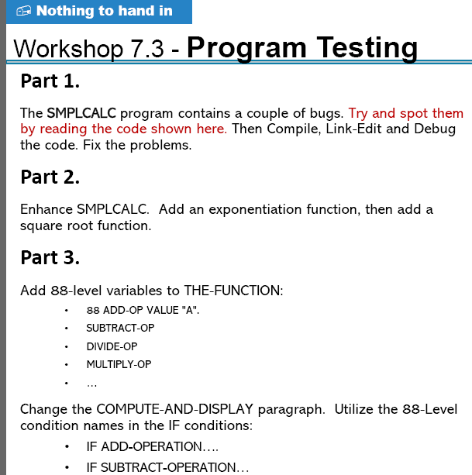

Answer :

Error was there due to the numbers of program lines ( were not in order ) , removal of error done by reorder .

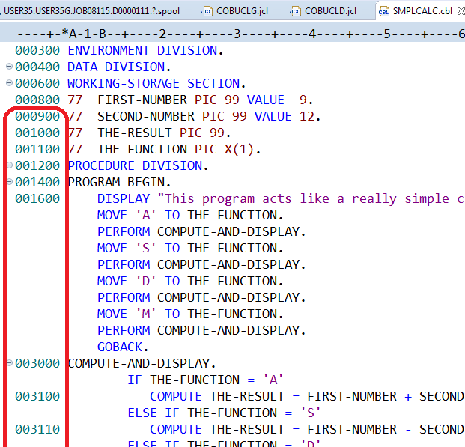

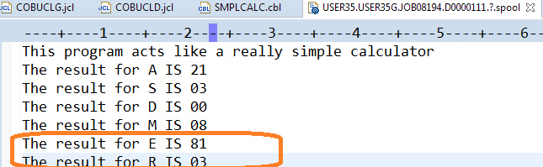

000100 IDENTIFICATION DIVISION. 00000100

000200 PROGRAM-ID. SMPLCALC. 00000200

000300 ENVIRONMENT DIVISION. 00000300

000400 DATA DIVISION. 00000400

000600 WORKING-STORAGE SECTION. 00000500

000800 77 FIRST-NUMBER PIC 99 VALUE 9. 00000600

000900 77 SECOND-NUMBER PIC 99 VALUE 12. 00000700

001000 77 THE-RESULT PIC 99. 00000800

001100 77 THE-FUNCTION PIC X(1).

88 ADDTION VALUE 'A' .

88 SUBTRACTION VALUE 'S' .

88 DIVISION-BY VALUE 'D' .

88 MULTIPLICATION VALUE 'M' .

88 EXPONENT VALUE 'E' .

88 SQURE-ROOT VALUE 'R' .

001200 PROCEDURE DIVISION. 00001000

001400 PROGRAM-BEGIN. 00001100

001600 DISPLAY "This program acts like a really simple calculator". 00001200

MOVE 'A' TO THE-FUNCTION. 00001300

PERFORM COMPUTE-AND-DISPLAY. 0000

MOVE 'S' TO THE-FUNCTION. 00001500

PERFORM COMPUTE-AND-DISPLAY. 0000

MOVE 'D' TO THE-FUNCTION. 00001700

PERFORM COMPUTE-AND-DISPLAY. 0000

MOVE 'M' TO THE-FUNCTION. 00001900

PERFORM COMPUTE-AND-DISPLAY.

MOVE 'E' TO THE-FUNCTION. 00001900

PERFORM COMPUTE-AND-DISPLAY.

MOVE 'R' TO THE-FUNCTION. 00001900

PERFORM COMPUTE-AND-DISPLAY. 0000

GOBACK. 00002100

003000 COMPUTE-AND-DISPLAY. 00002200

IF ADDTION

003100 COMPUTE THE-RESULT = FIRST-NUMBER + SECOND-NUMBER 00002400

ELSE IF SUBTRACTION

003110 COMPUTE THE-RESULT = FIRST-NUMBER - SECOND-NUMBER 00002600

ELSE IF DIVISION-BY

003120 COMPUTE THE-RESULT = FIRST-NUMBER / SECOND-NUMBER 00002800

ELSE IF MULTIPLICATION

003130 COMPUTE THE-RESULT = FIRST-NUMBER \* SECOND-NUMBER

ELSE IF SQURE-ROOT

003132 COMPUTE THE-RESULT = FIRST-NUMBER \*\* (0.5)

ELSE IF EXPONENT

003133 COMPUTE THE-RESULT = FIRST-NUMBER \*\* SECOND-NUMBER.

003300 DISPLAY "The result for " THE-FUNCTION " IS " THE-RESULT. 00003100

Question 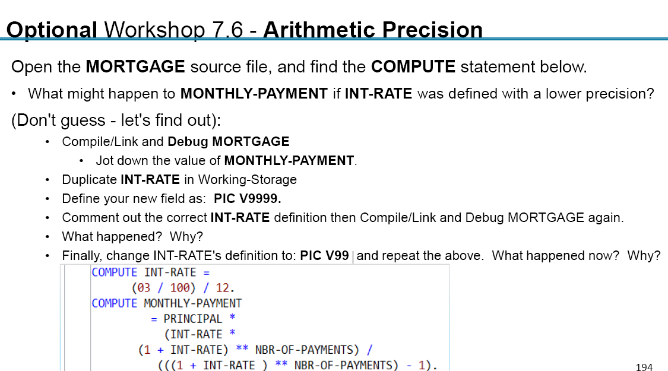

Answer :

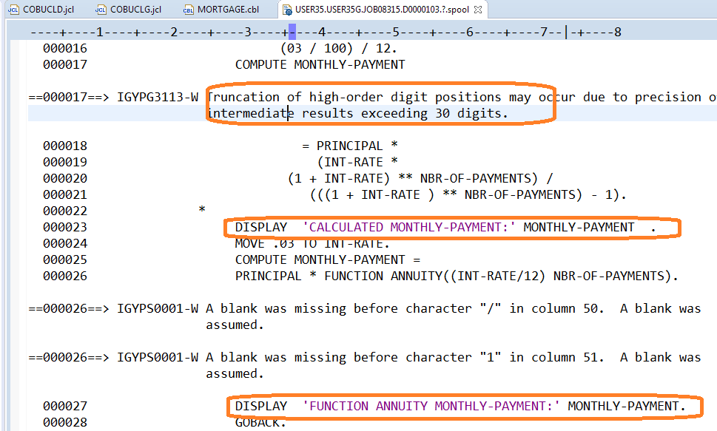

conclusions :

1. To avoid truncation the computed data item must be with many decimal positions , also rearrange the compute (make the multiplication operations before the divide operation.
2. if there is an intrinsic Cobol function , Use it , it is ALWAYS accurate . (also it makes the code very readable ) .

Question? :

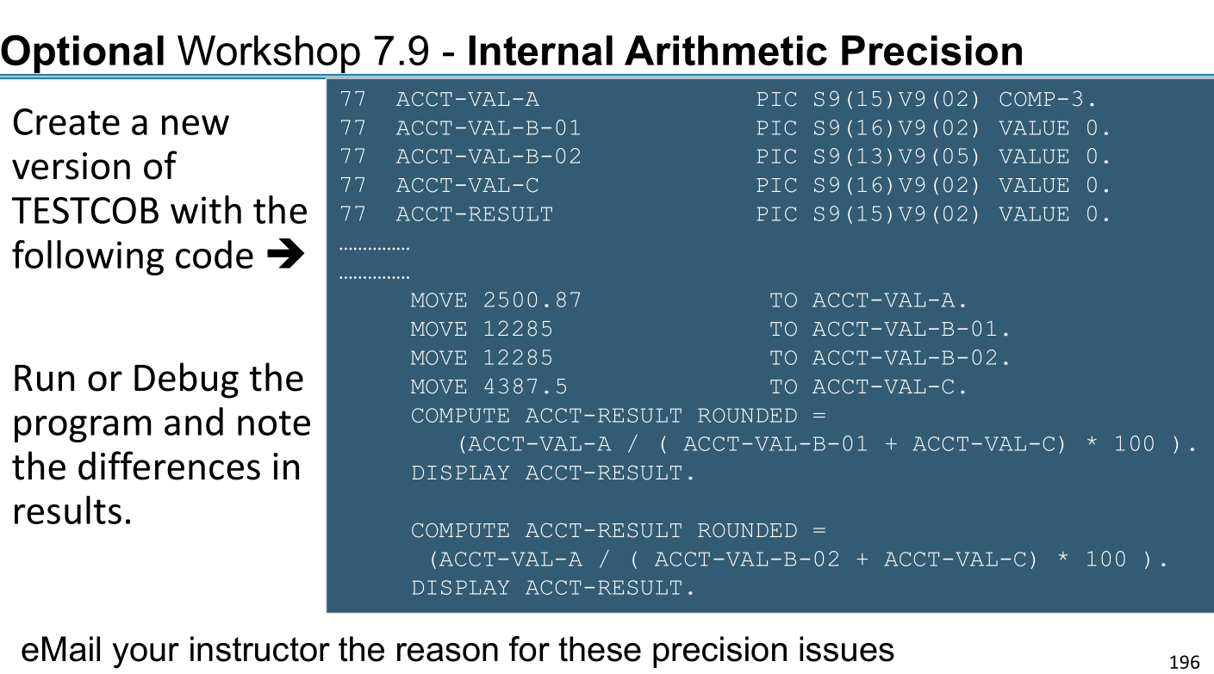

Answer :

<https://stackoverflow.com/questions/25127356/cobol-compute-issues>

modified solutiion

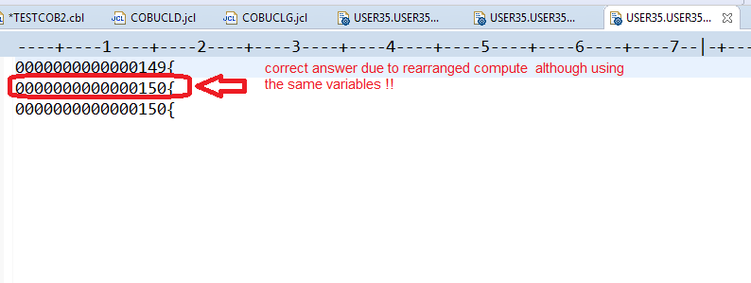

IDENTIFICATION DIVISION.

PROGRAM-ID. TESTCOB2.

\* Comment: This program Displays a number of text strings

ENVIRONMENT DIVISION.

DATA DIVISION.

WORKING-STORAGE SECTION.

77 ACCT-VAL-A PIC S9(15)V9(02) COMP-3 .

77 ACCT-VAL-B-01 PIC S9(16)V9(02) VALUE 0.

77 ACCT-VAL-B-02 PIC S9(13)V9(05) VALUE 0 .

77 ACCT-VAL-C PIC S9(16)V9(02) VALUE 0 .

77 ACCT-RESULT PIC S9(15)V9(02) VALUE 0 .

PROCEDURE DIVISION.

MOVE 2500.87 TO ACCT-VAL-A

MOVE 12285 TO ACCT-VAL-B-01

MOVE 12285 TO ACCT-VAL-B-02

MOVE 4387.5 TO ACCT-VAL-C

COMPUTE ACCT-RESULT ROUNDED =

(ACCT-VAL-A / ( ACCT-VAL-B-01 + ACCT-VAL-C) \* 100 ).

DISPLAY ACCT-RESULT

\* The actual problem is a poorly-formed COMPUTE.

\* TRY TO Do

\* multiplication first =>which increase the value

\* ( or even elemenate ) decimal postions ==> no rounding

\* and do the division at last ...to just make round one time

\*https://stackoverflow.com/questions/25127356/cobol-compute-issues

\* Corrected answer due to rearranged compute

COMPUTE ACCT-RESULT ROUNDED =

ACCT-VAL-A \* 100 / ( ACCT-VAL-B-01 + ACCT-VAL-C) .

DISPLAY ACCT-RESULT

COMPUTE ACCT-RESULT ROUNDED =

(ACCT-VAL-A / ( ACCT-VAL-B-02 + ACCT-VAL-C) \* 100 ).

DISPLAY ACCT-RESULT

GOBACK.